

**Dynamics 365 - Request for Quotation Creation**

**Revision 1**

**Revision History**

|  |  |  |  |  |
| --- | --- | --- | --- | --- |
| **Date** | **Revision** | **Description** | **Signature / Date** | |
| 10/17/2022 | 1 | Initial draft of user manual: Dynamics 365 - Request for Quotation Creation - Rev 1 | Prepared | Waseem Abbas |
|  |  | Verified | Alamgir Tamoori |
|  |  | Approved |  |
|  |  |  | Prepared |  |
|  |  | Verified |  |
|  |  | Approved |  |
|  |  |  | Prepared |  |
|  |  |  |  |
|  |  |  |  |
|  |  |  |  |  |
|  |  |  |  |
|  |  |  |  |

**Table of Contents**

1 About User Manual 5

2 Dynamics 365 – RFQ Page 5

3 Creation of New Request for Quotation 6

3.1 Request for Quotation – Lines 7

3.2 Request for Quotation – Header 7

3.3 Send the RFQ 8

4 Response on RFQ confirmation from Vendor 9

4.1 RFQ Status 9

4.2 Accepting RFQ 10

List of Figures

Figure 1. Dynamics 365 – Process to open all requests for quotations page 5

Figure 2. Dynamics 365 - All RFQs 5

Figure 3. Enter the required details in the header panel 6

Figure 4. Enter the details in the quotation lines 7

Figure 5. After entering all details, click on the ‘Send’ button 8

Figure 6. Status of RFQ 9

Figure 7. Accept the Quote shared by Vendor 10

# About User Manual

This document describes the step-by-step guide for creation of Request for Quotation (RFQ). It is a process in which company acquire the prices for some particular items or products. The company floats the request for quotation to different suppliers and select the supplier based on the best lowest quotation/rates.

In this manual, the procedure of creating Request for Quotation will be briefed out.

# Dynamics 365 – RFQ Page

To access the RFQ page, click on the modules and select the ‘Procurement and sourcing’. Click on the ‘**All requests for quotations**’ option available under the Request for Quotations.

**Navigation**: Modules > Procurement and Sourcing > All requests for quotations

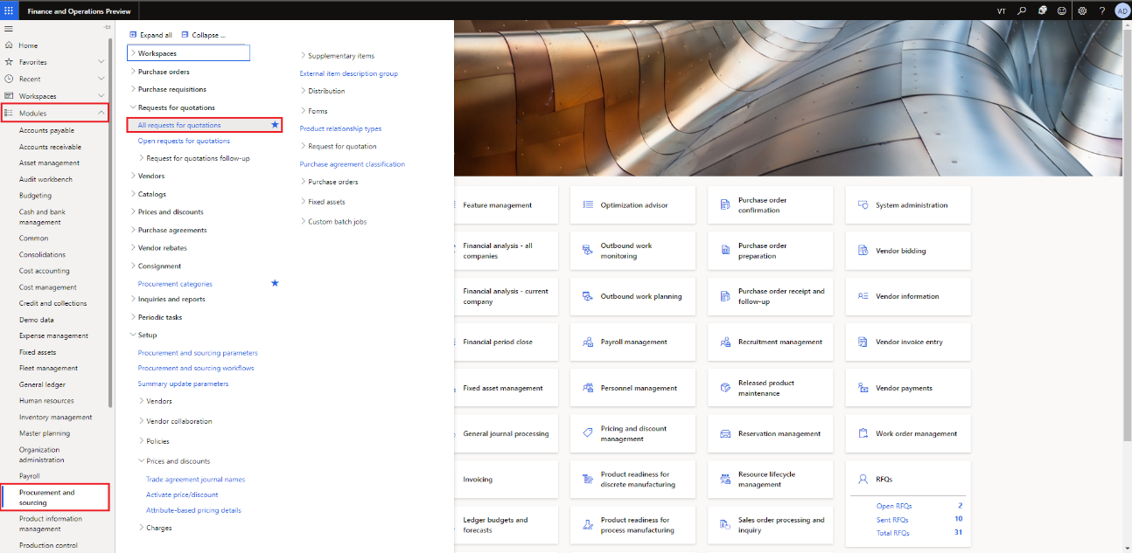

Figure 1. Dynamics 365 – Process to open all requests for quotations page

On pressing the All request for quotations option, all RFQ page will open up.

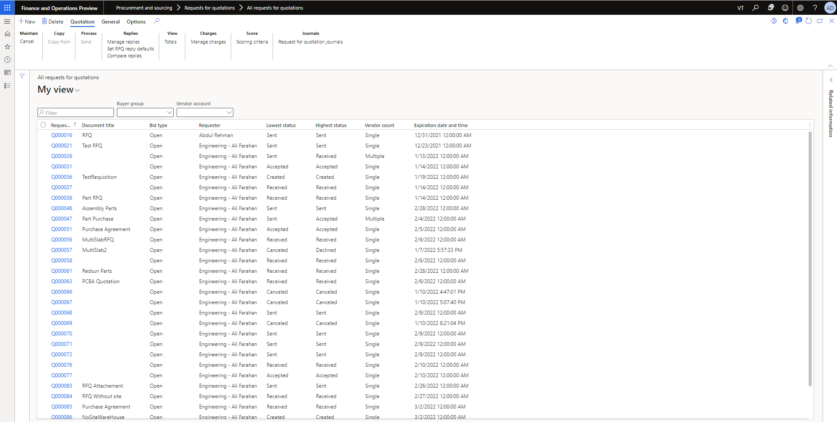

Figure 2. Dynamics 365 - All RFQs

# Creation of New Request for Quotation

Navigation: Modules > Procurement and Sourcing > All requests for quotations > New

To create new request for quotation, select the ‘New’ option located on the top left. Add up the details in the fields. In the Purchase type field, three options will be available:

1. Purchase Order
2. Purchase Requisition
3. Purchase agreement

In **Purchase Order** option, it is the kind of purchase type that confirms the offer to buy products or the acceptance of an offer to sell products in exchange for payment.

In **Purchase Requisition** option, this type is selected automatically if the RFQ is created directly from a purchase requisition. If this option is selected manually, an error will be encountered.

In **Purchase Agreement** option,in this type of agreement to purchase a specific quantity or value of product over some particular time. If this option is selected, then select the date range that applies to the purchase agreement.

In the **Document title** field, type a value.

In the **Solicitation type** field, select the RFQ – Raw Material option. It is used to purchase raw materials.

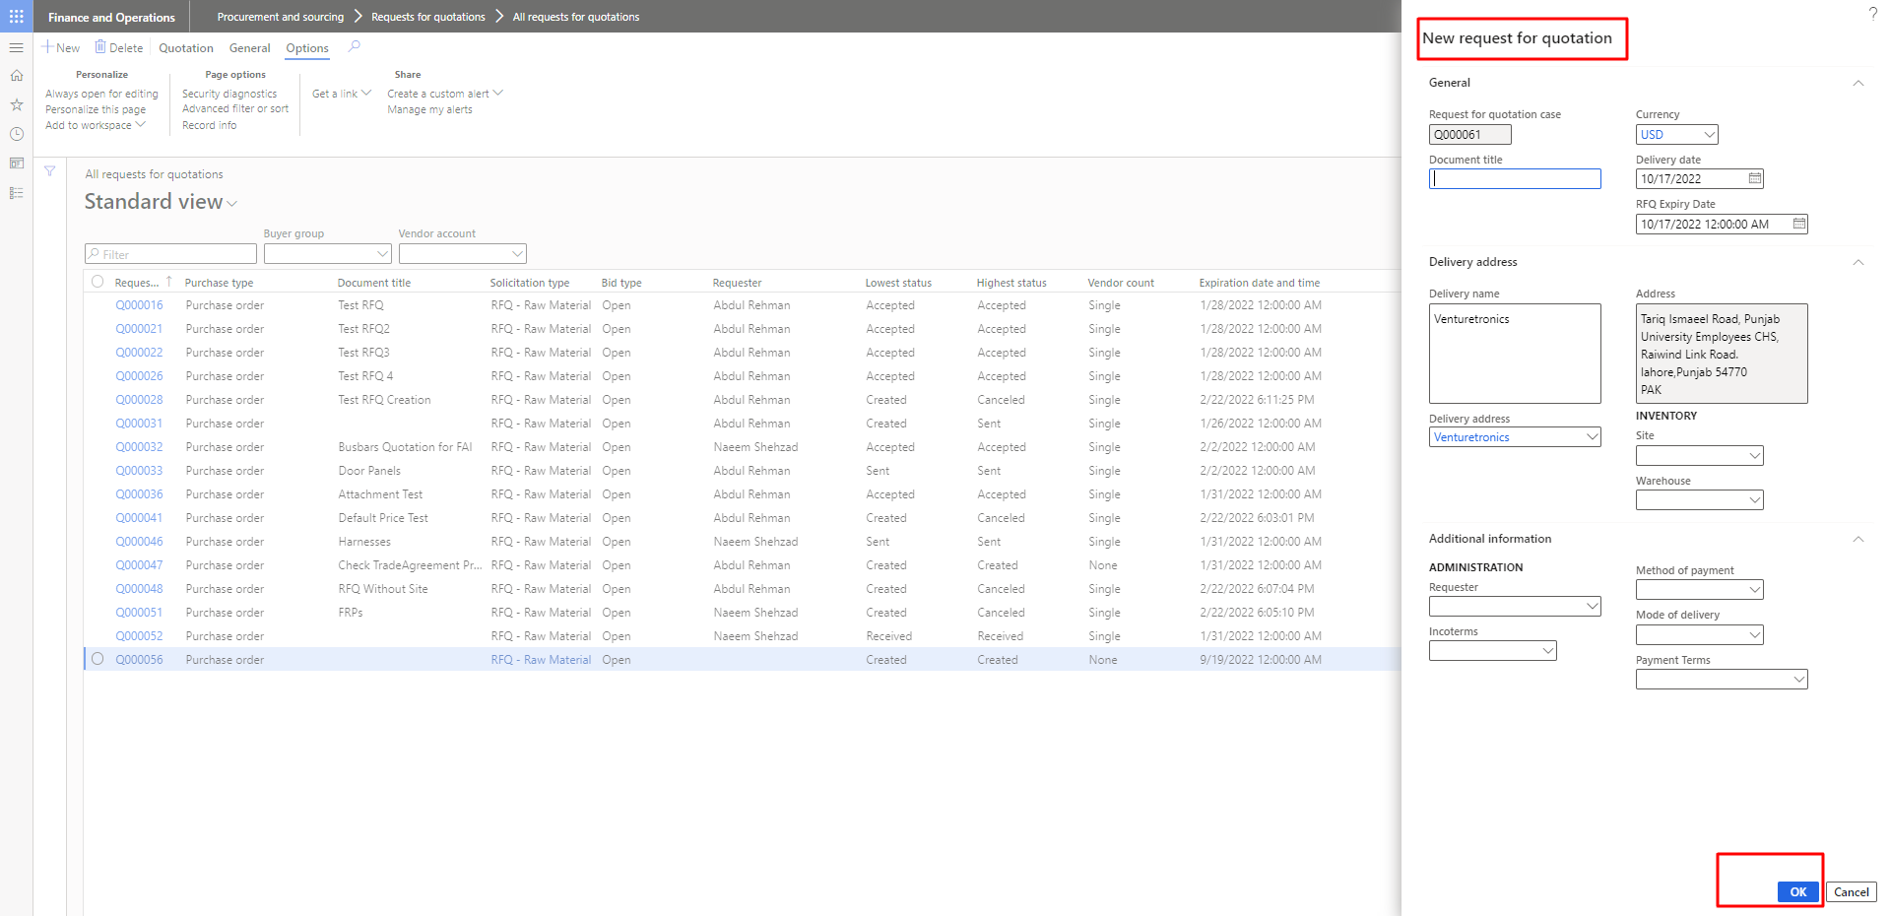

Figure 3. Enter the required details in the header panel

## ****Request for Quotation – Lines****

**Navigation**: Modules > Procurement and Sourcing > All requests for quotations > New > Lines

After adding the basic information about your RFQ, you will specify the parts or categories that you want vendors to bid on. In the line type field, select the line is an “**item**” or “**Category**”. Line number will be automatically generated by the system. Select the Item number/item category in the item number field. Select the desired warehouse and site in the ‘**site’** and ‘**warehouse’** category.

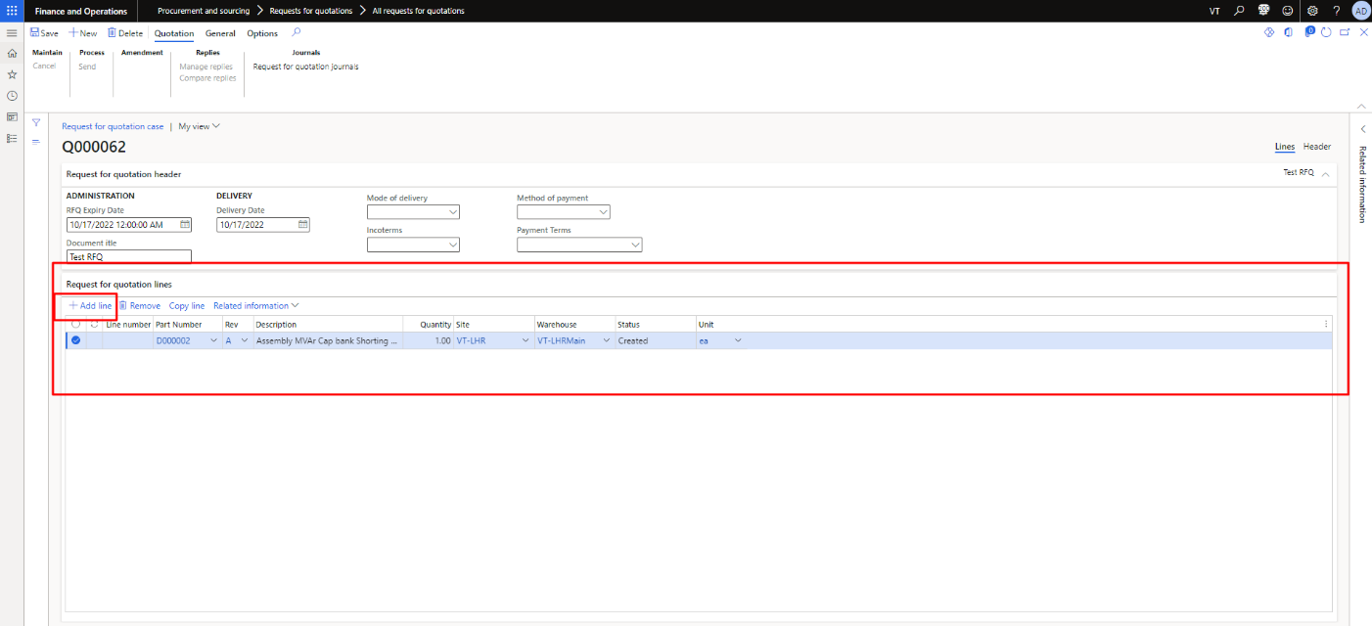

Figure 4. Enter the details in the quotation lines

## Request for Quotation – Header

**Navigation**: Modules > Procurement and Sourcing > All requests for quotations > New > Header

Enter the details in the header panel. In the vendor tab, select the vendors to send the bid invites. Enter any RFQ related details in the RFQ description. To add a vendor, click on the ‘Add’ button and click the drop down in the ‘Vendor Account’ and select the vendor. Repeat this process until you have selected all the desired vendors for the specific bid. After selecting vendors, the data on the other field will auto-populate. The ‘Lowest’ and ‘Highest status’ fields will used to show which of the vendor’s bids selected. The ‘Rank’ and ‘Total score’ fields will be active after we enter replies for our vendors.

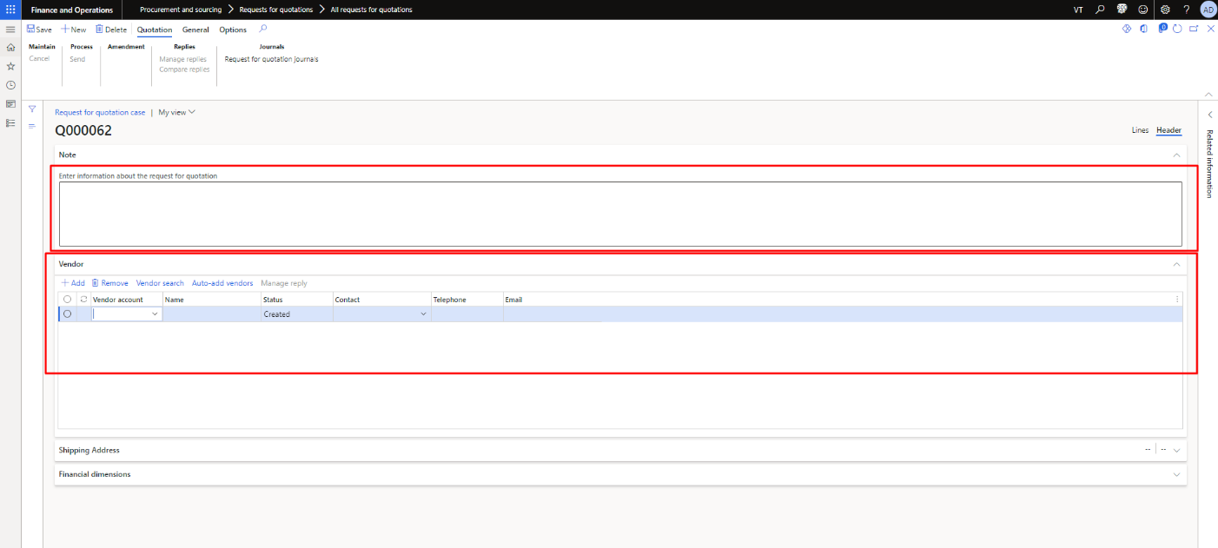

Figure 5. RFQ – Header panel

Add the currency and payment fields. Also add the details in the financial dimensions.

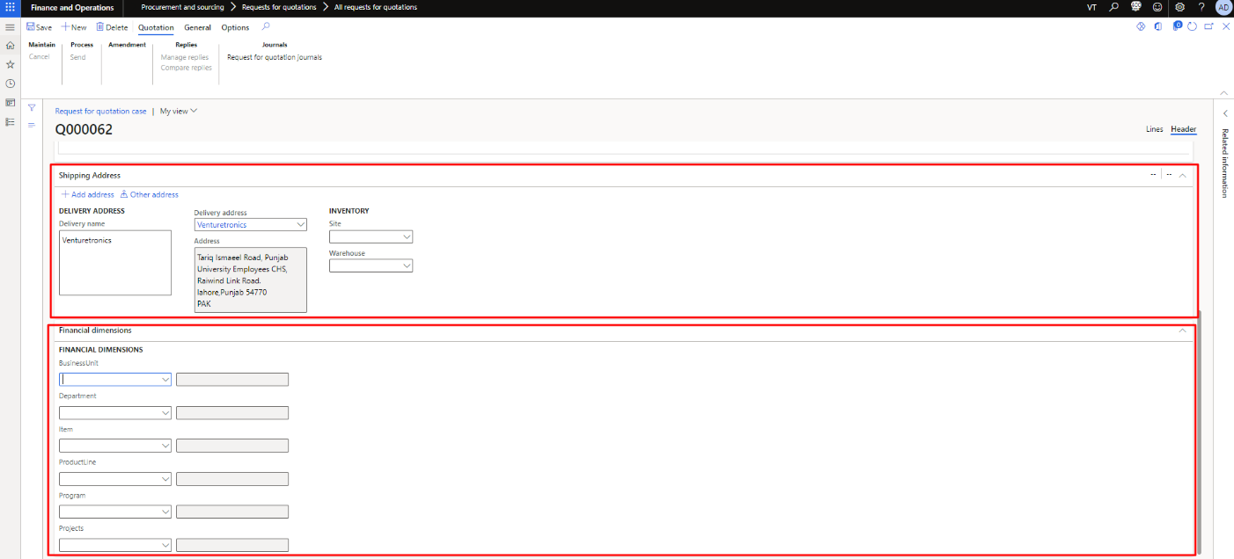

Figure 6. RFQ - Price Discount & financial dimension

## Send the RFQ

**Navigation**: Modules > Procurement and Sourcing > All requests for quotations > Process > Send

To send the RFQ, click the “**Quotation**” tab available on the top. In the Sending request for quotation page, check that the vendors in the list are the ones that you want to send the RFQ.

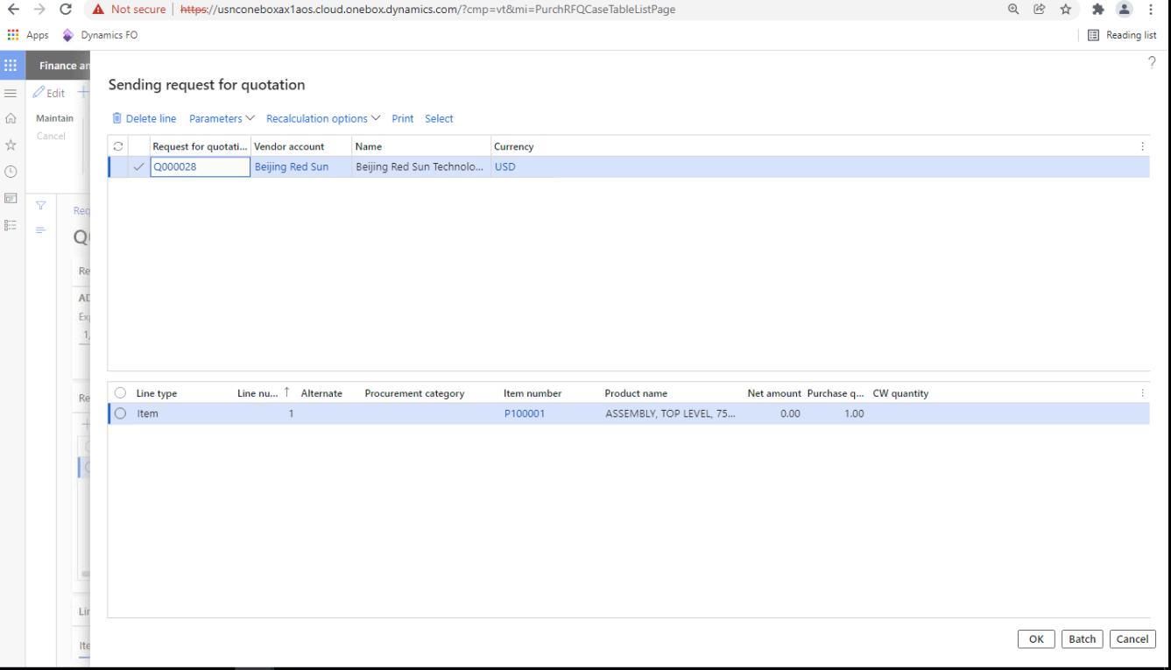

Figure 5. After entering all details, click on the ‘Send’ button

# Response on RFQ confirmation from Vendor

## RFQ Status

**Navigation**: Modules > Procurement and Sourcing > All requests for quotations

After the RFQ received or accepted by designated vendor, the labels of lowest and highest status will be changed from sent to received.

The status of a request for quotation (RFQ) is shown in the RFQ header and depends on the statuses of the RFQ lines. The status specifies the extent to which you have processed the RFQ. Each RFQ has two values for the status: lowest and highest. The lowest status is the least advanced stage of any line in the RFQ and the highest status is the most advanced stage of any line in the RFQ. For example, if the least advanced stage in an RFQ is for a line that has been created, the lowest status for the RFQ is Created. If the most advanced stage in the RFQ is for a line that has been sent to vendors, the highest status for the RFQ is Sent. The statuses are automatically updated as you process an RFQ.

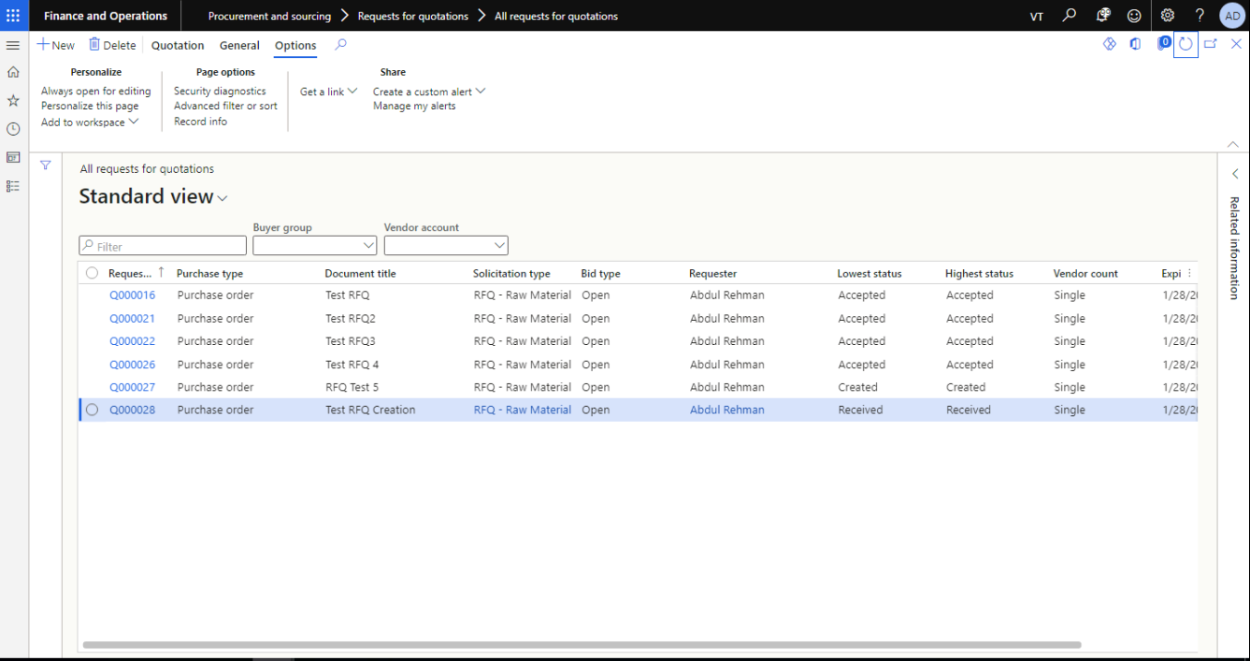

Figure 6. Status of RFQ

## Accepting RFQ

**Navigation**: Modules > Procurement and Sourcing > All requests for quotations > Reply > Process > Accept

After the vendor response, accept the quote that is submitted by the vendor.

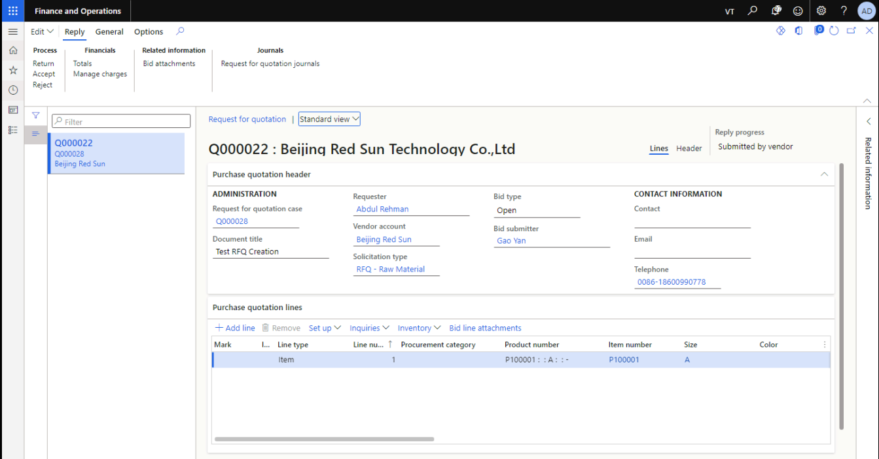

Figure 7. Accept the Quote shared by Vendor